

High Level Design & Low Level Design

**Index**

1. Introduction ------------------------------------------------ 3

1.1 Intended audience ------------------------------------------------ 3

1.2 Project purpose ------------------------------------------------ 3

1.3 Key project objective ------------------------------------------------ 3

1.4 Project scope ------------------------------------------------ 4

2. Design overview ------------------------------------------------ 4

2.1 Design objective ------------------------------------------------ 6

2.2 Design alternative ------------------------------------------------ 6

2.3 User interface paradigms ------------------------------------------------ 6

2.4 Validations ------------------------------------------------6

3. Detailed system design -------------------------------------------------9

4.1 Flowchart of main application ------------------------------------------------9

4.2 Flowchart of maintain database() ------------------------------------------------10

4.3 Flowchart of main menu ------------------------------------------------11

4.4 Flowchart of show report() ------------------------------------------------12

4. Tools Report -------------------------------------------------13

5.1 CUnit ------------------------------------------------13

5.2 Valgrind ------------------------------------------------13

5.3 Gprof ------------------------------------------------14

5.1 Gcov ------------------------------------------------15

6. Testing ------------------------------------------------24

6.1 Unit Testing ------------------------------------------------24

6.2 Integration Testing —---------------------------------------------25

7. Requirements Traceability Matrix(RTM) ------------------------------------------------30

1. **Introduction**

The remote calculator is specifically developed for calculation with facilities of addition, subtraction, multiplication, division and exponentiation. Secondly, the application also allows only the authorized user to login to perform the calculations. It works on the client server model where the client can use the calculator if and only if it enters the correct username and password.

**1.1 Intended Audience: -**

The target audience set for this project can be identified as a client who wants to perform some arithmetic calculations like addition, subtraction, multiplication and division.

**1.2 Project Purpose: -**

The remote calculator is a project that helps us understand the basic concepts of functions, socket programming , and data structures.

**1.3 Key Project Objectives: -**

1. Allow the client to be authenticated
2. Server asks for input from the client
3. Server calculates the answer
4. Server sends over the answer to the client
5. Answer is calculated according to the BODMAS rule.

**1.4 Project scope : -**

This project aims to create the development of an Remote calculator application. The remote calculator is specifically developed for calculation with facilities of addition, subtraction, multiplication, division and exponentiation. Secondly, the application also allows only the authorized user to login to perform the calculations. It works on the client server model where the client can use the calculator if and only if it enters the correct username and password.

**2. Design Overview: -**

## Design Objectives:

1. Add different bowler profiles to the records.
2. Start the scoring application.
3. Updating the scores for each frame and the total score.
4. Displays all the records of Bowler.
5. Modify/Update the Bowler records
6. Calculating the cumulative score.
   1. **Design Alternative: -**

We have used a stack data structure to evaluate the infix expression that is used to calculate the ultimate result.

### 2.3 User Interface Paradigms: -

The client can perform the calculations if it enters the correct username and password.

**3. DETAILED SYSTEM DESIGN:**

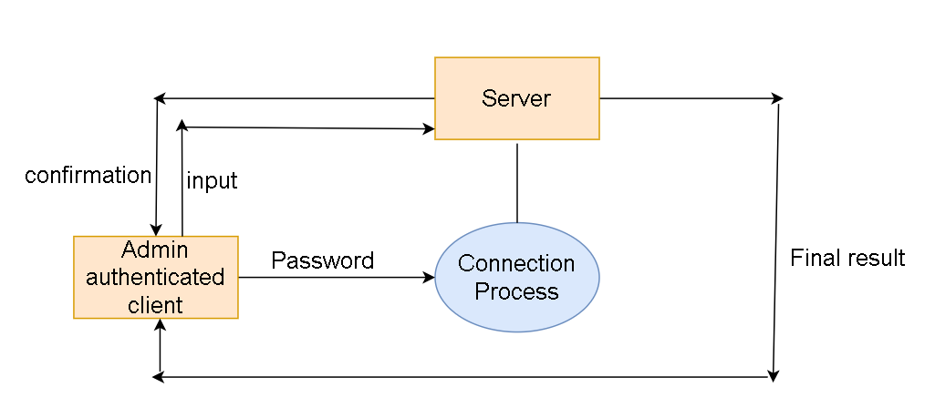

**4.1 DFD level 0**

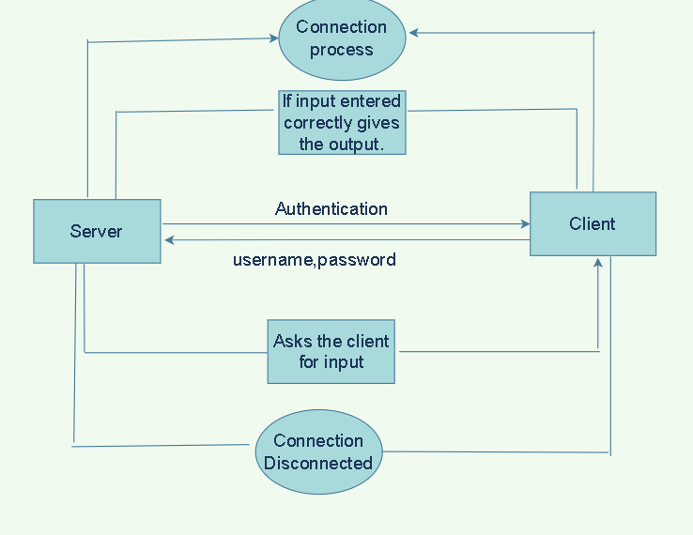

**4.2 DFD level 1**

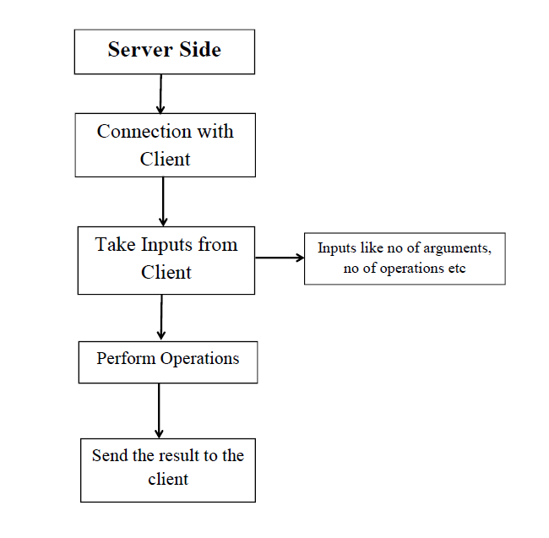

**4.3 Flow chart for server side of the application**

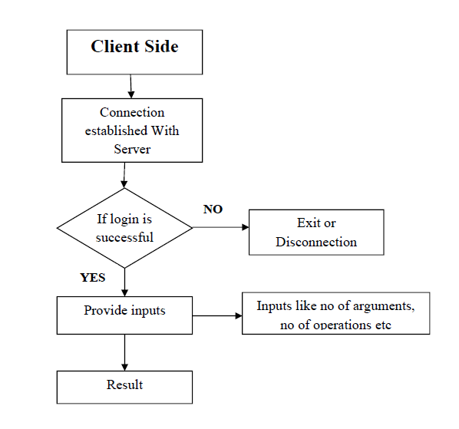

**4.4 Flow chart for Client side of the application**

**5. TOOLS REPORT**

**5.1 CUnit**

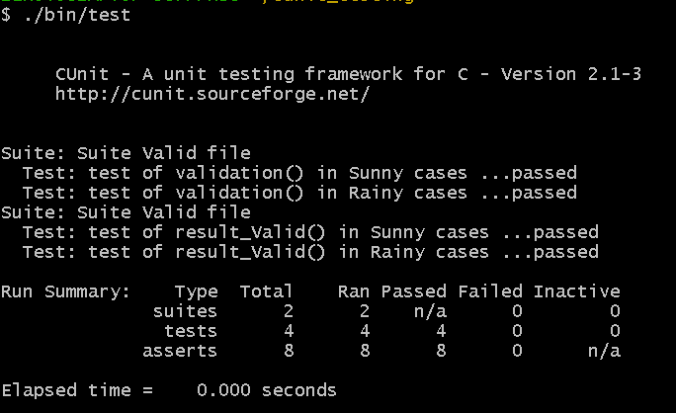

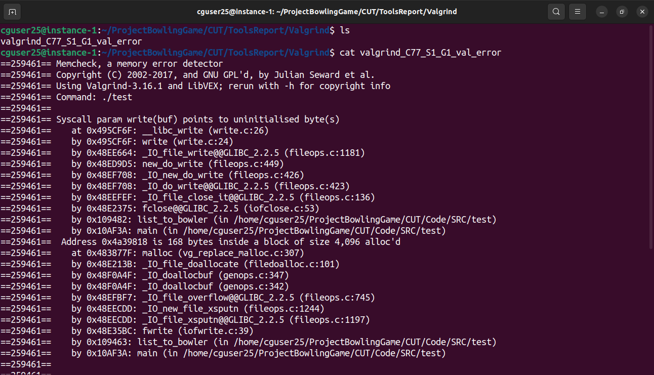

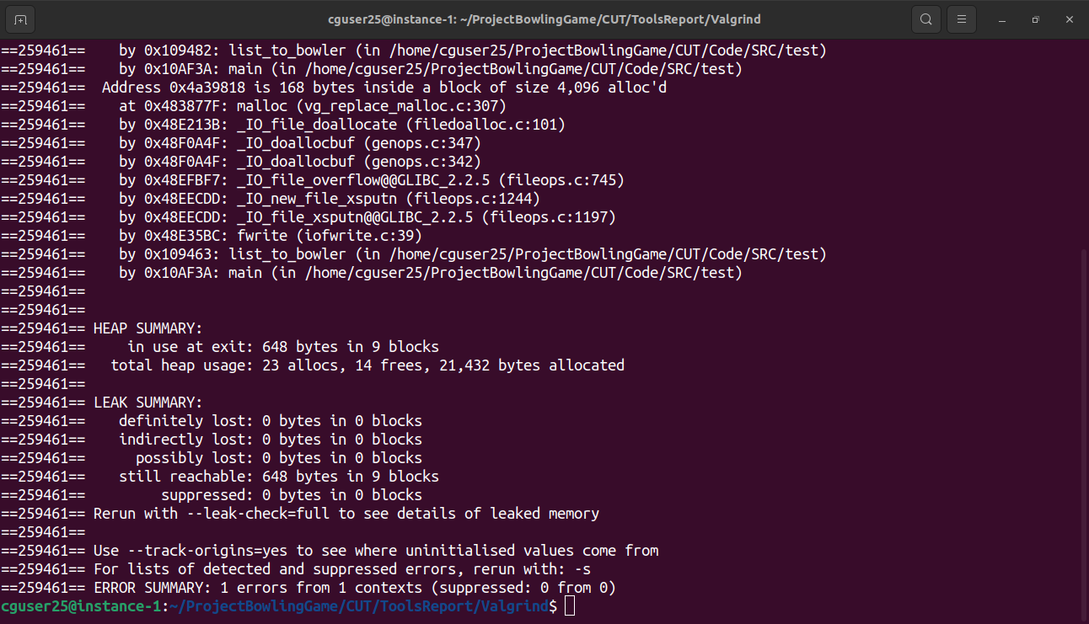

**5.3 Splint**

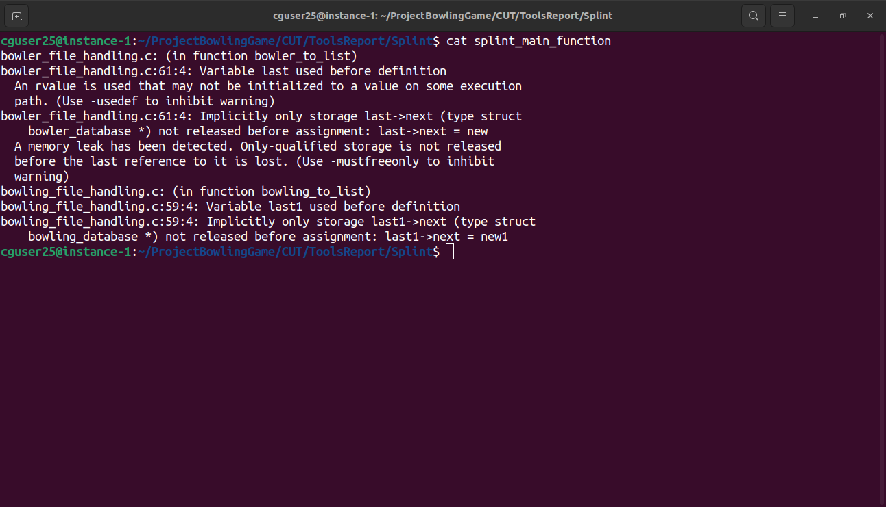

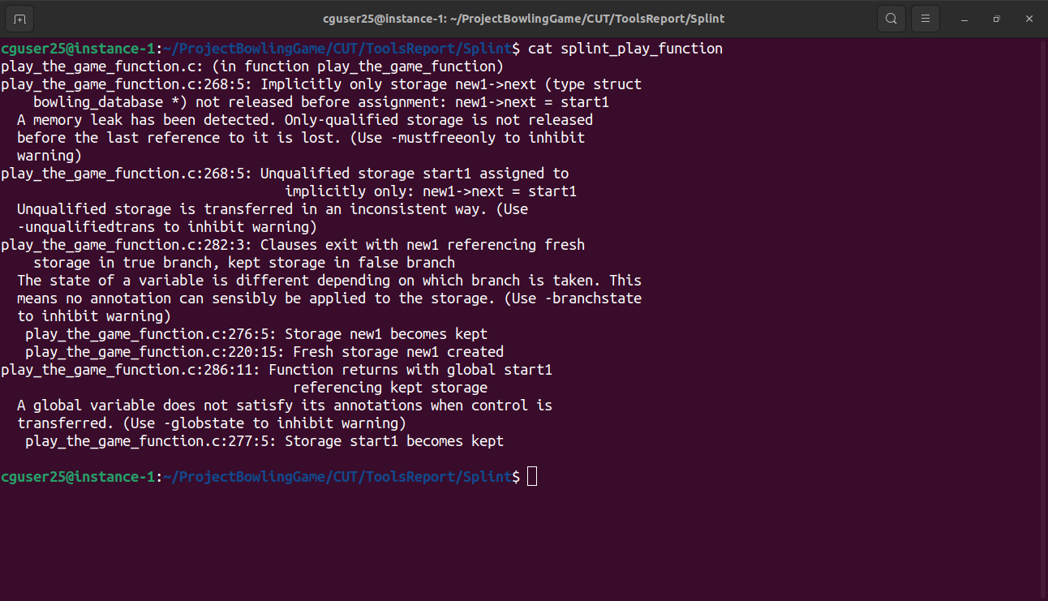

**5.4 Gcov**

**Main.c.gcov:**

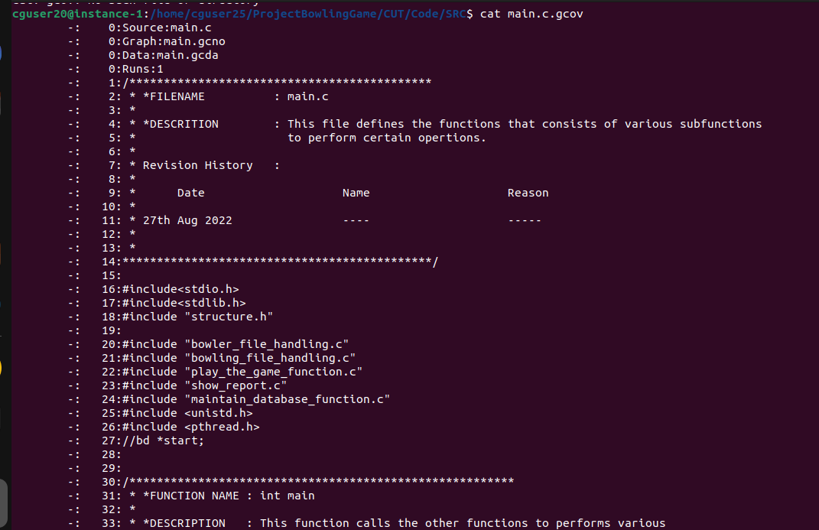

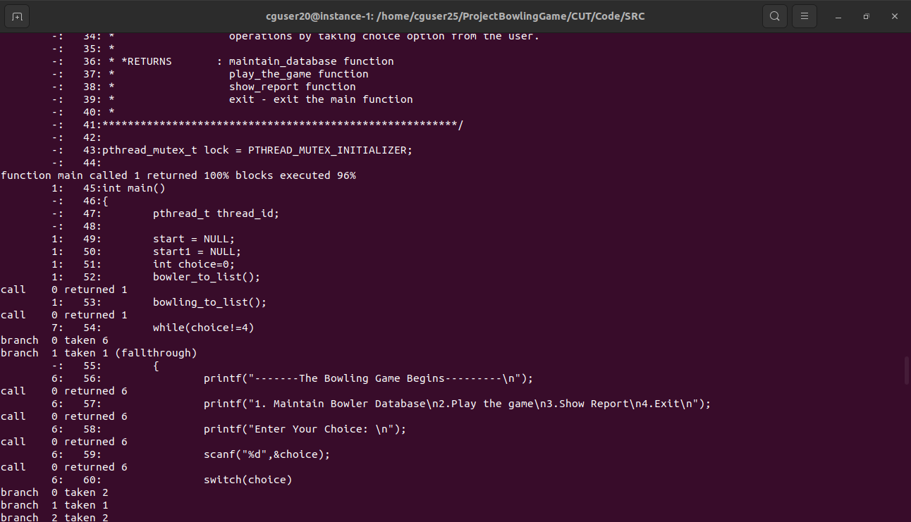

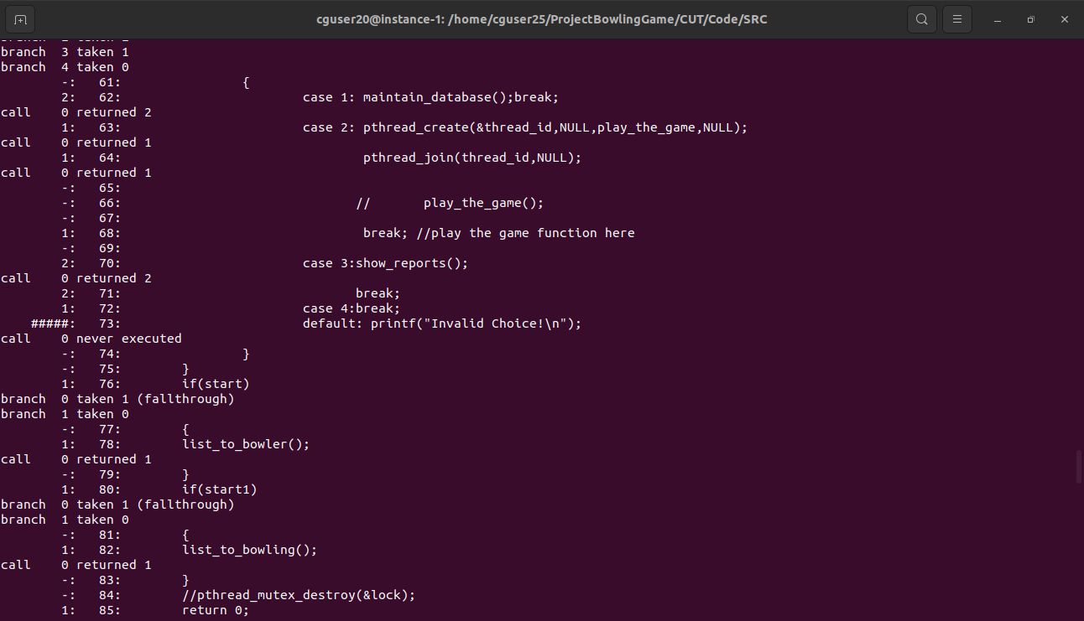

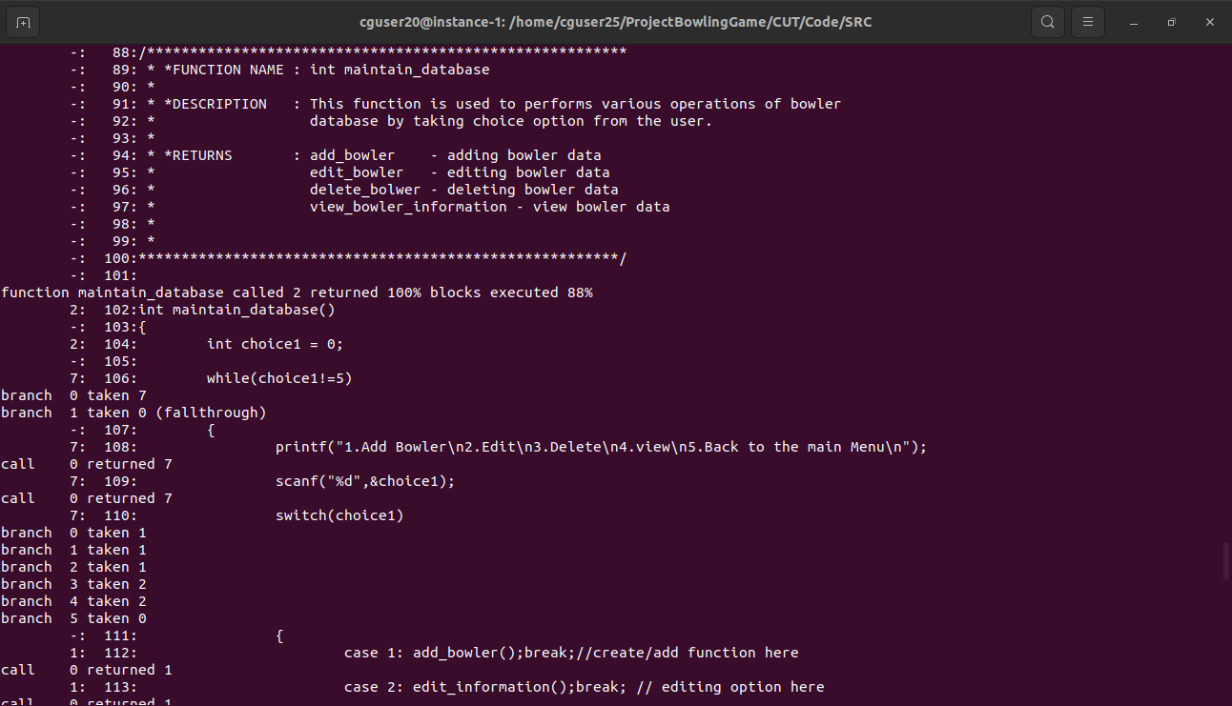

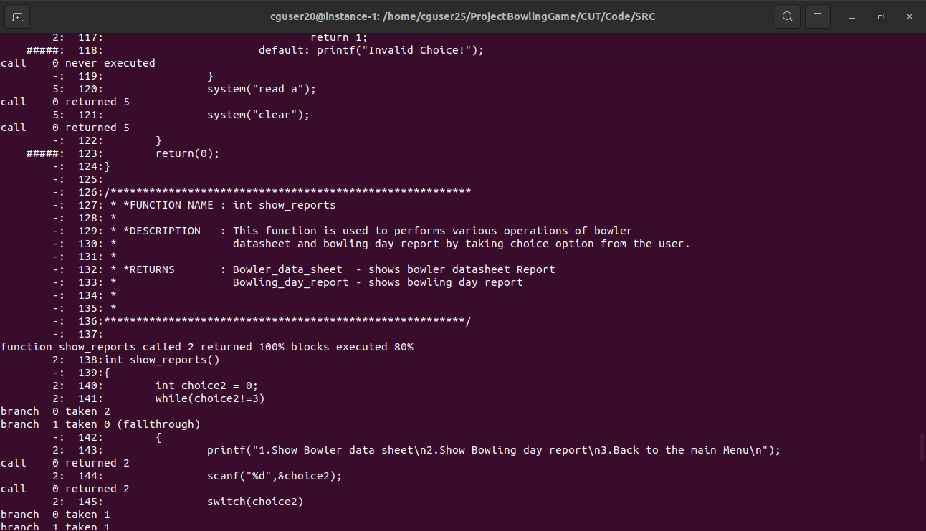

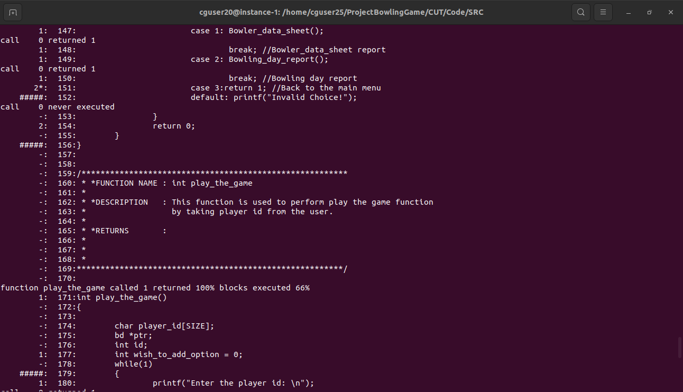

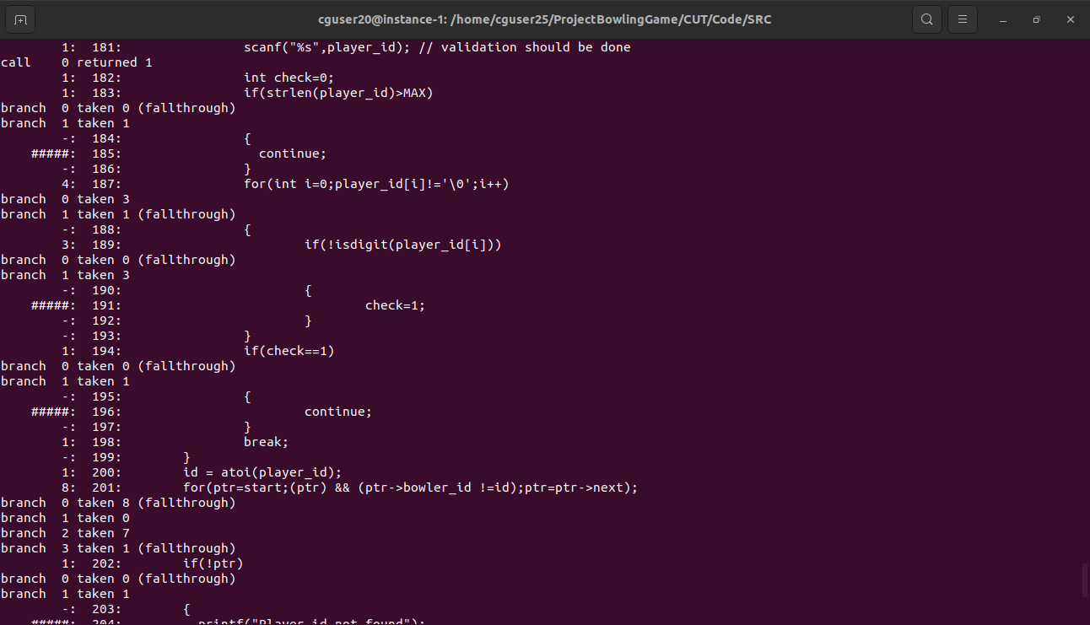

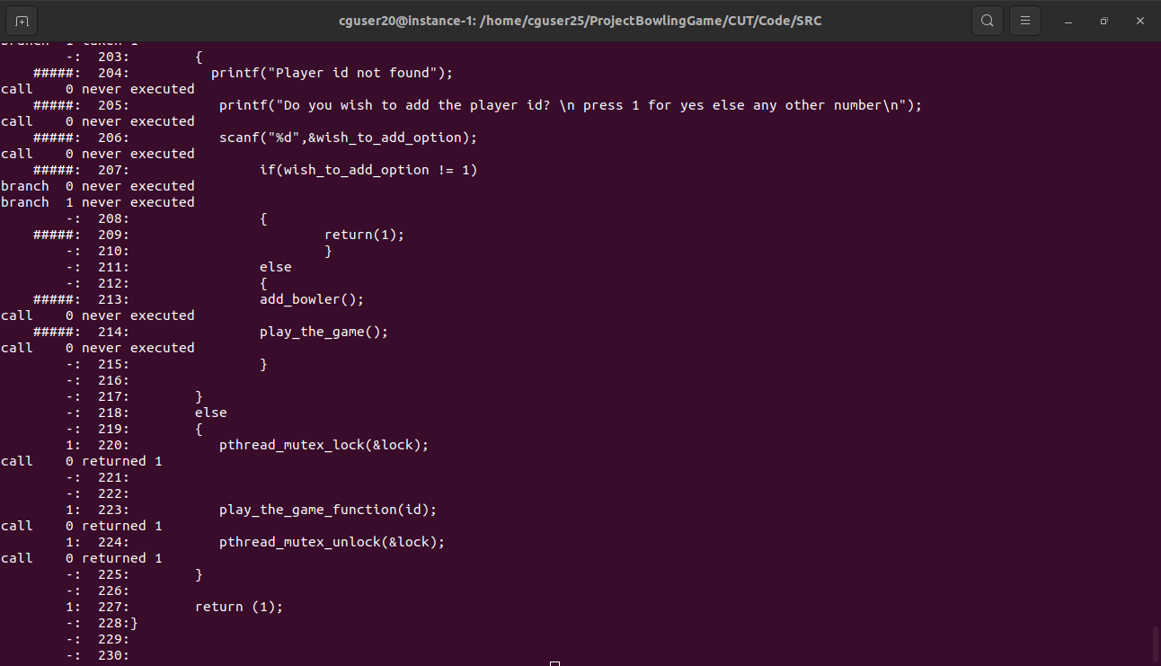

**Play_the_function.c.gcov**

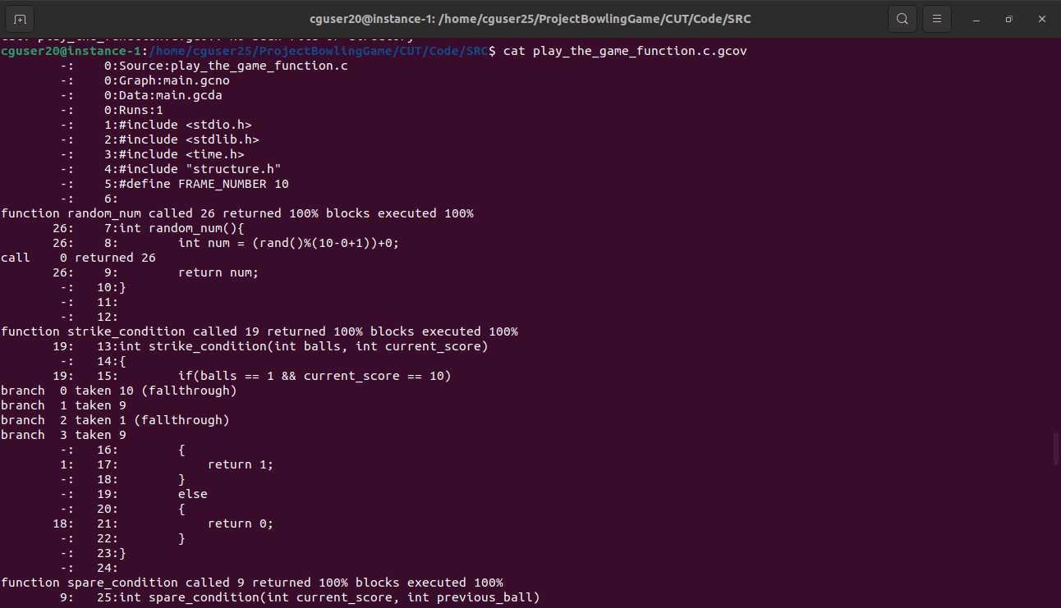

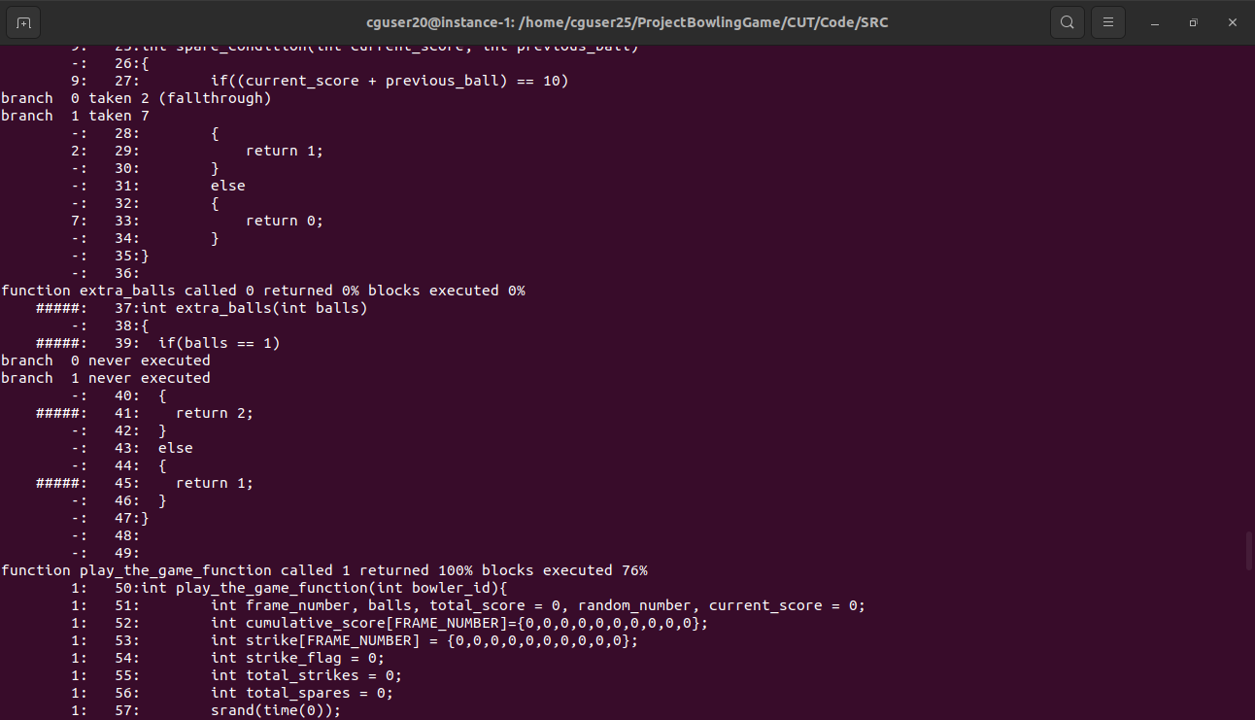

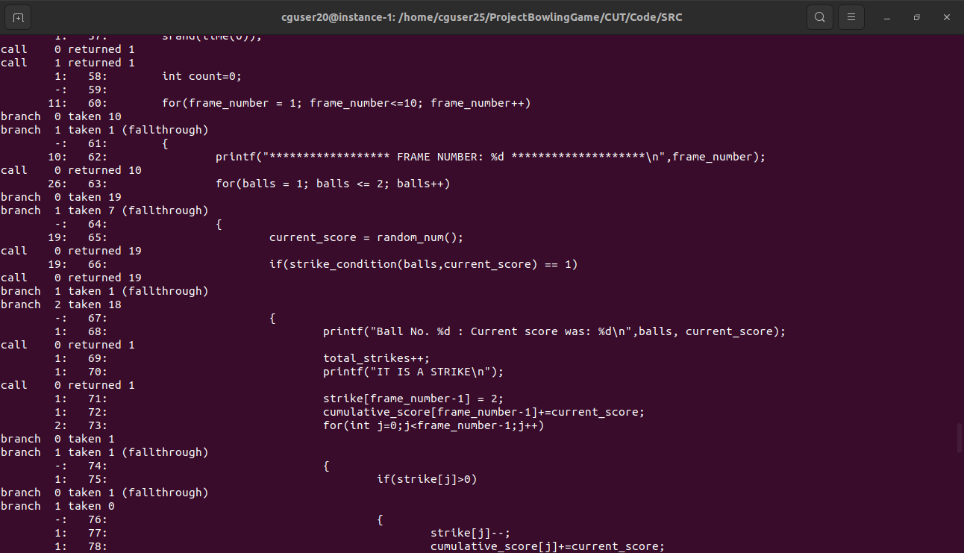

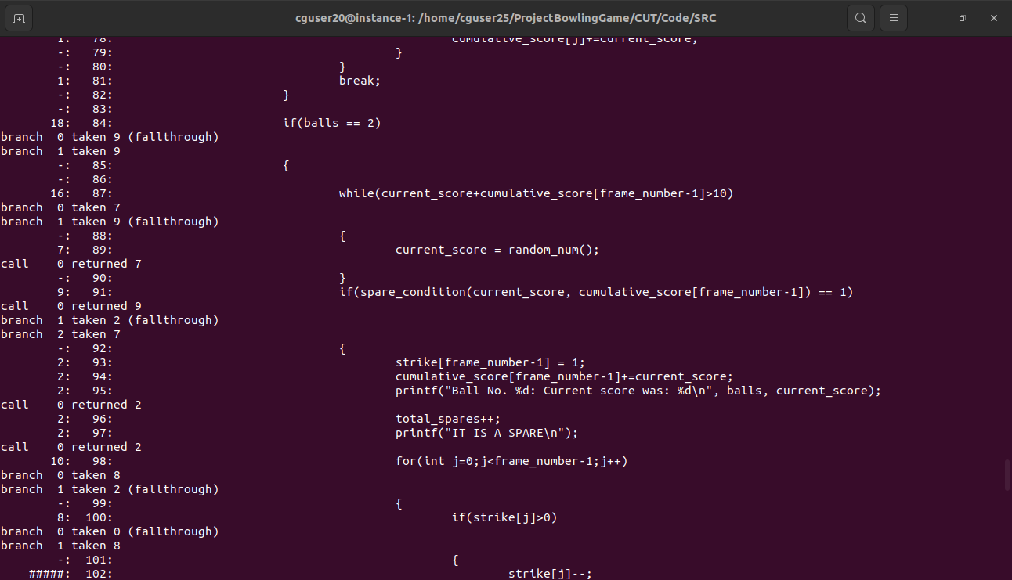

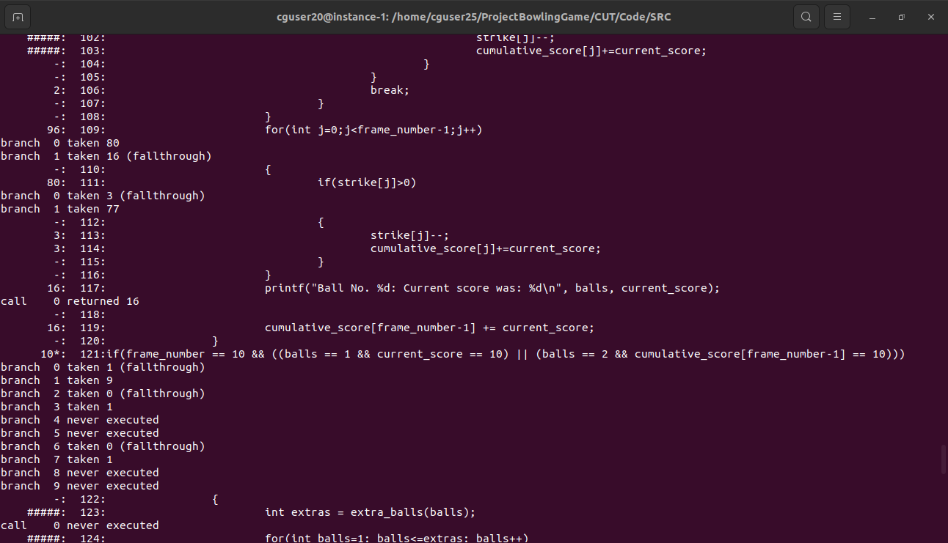

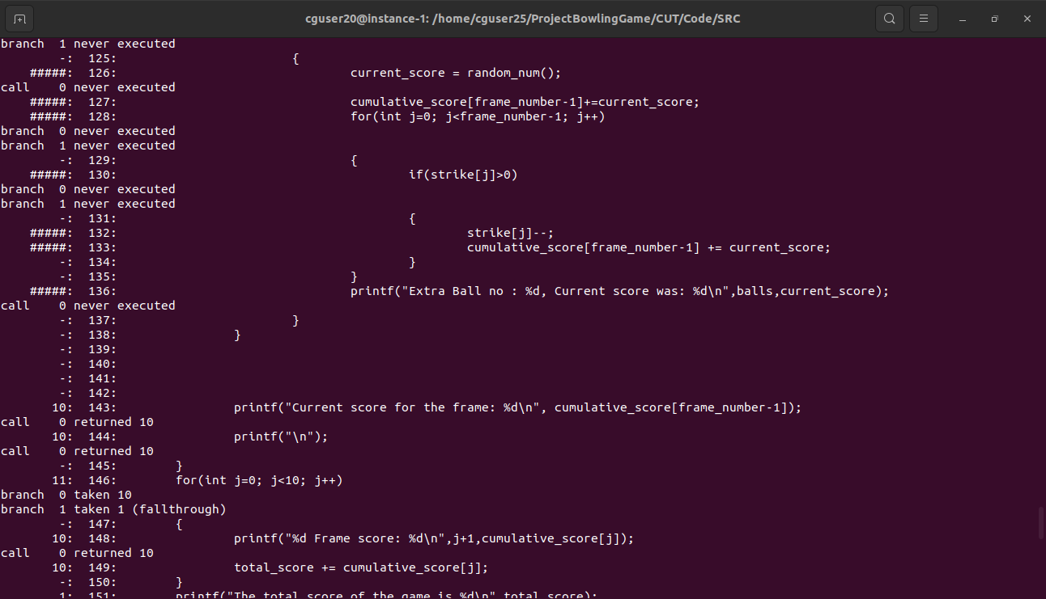

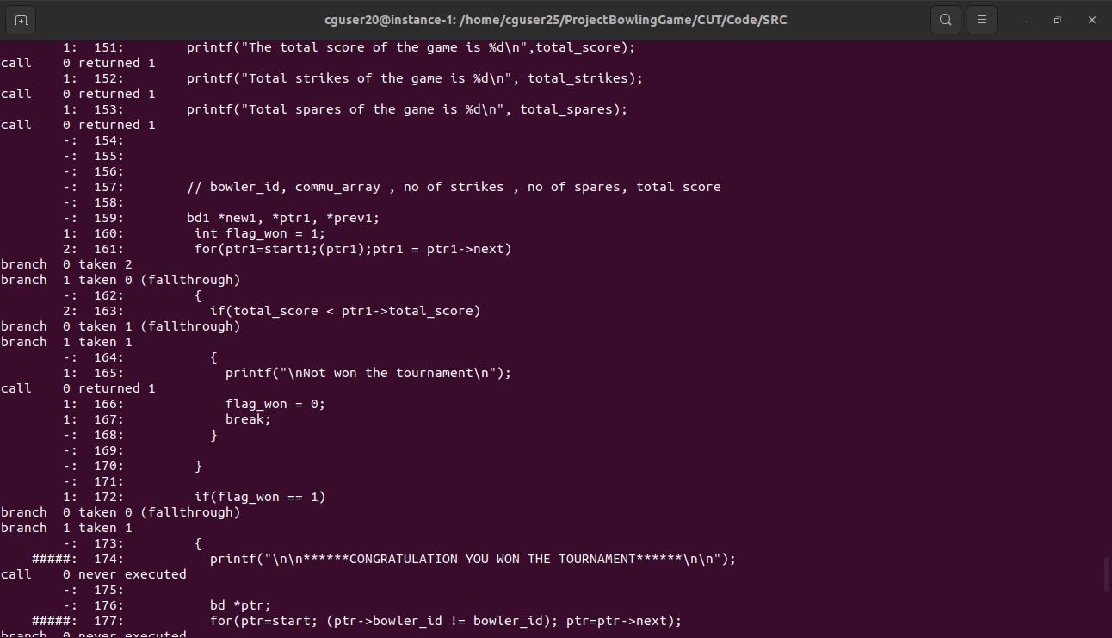

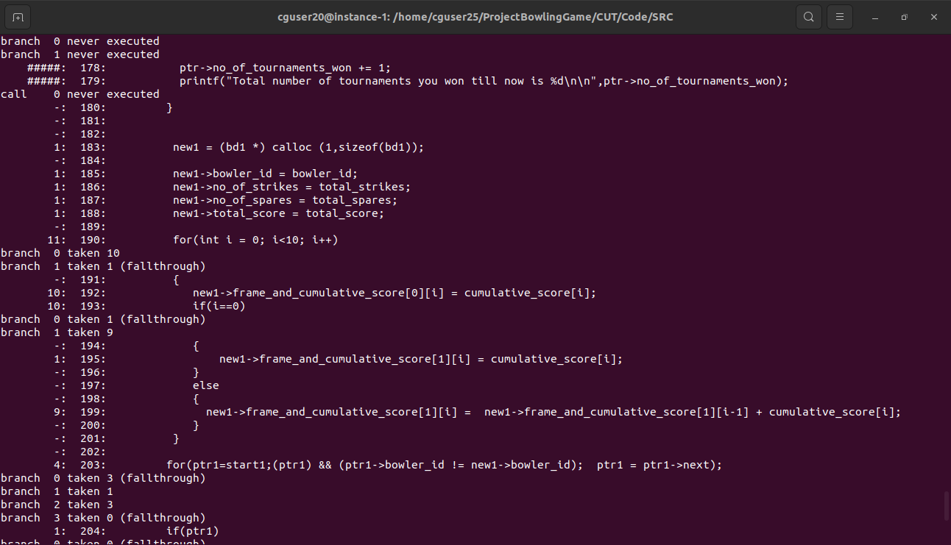

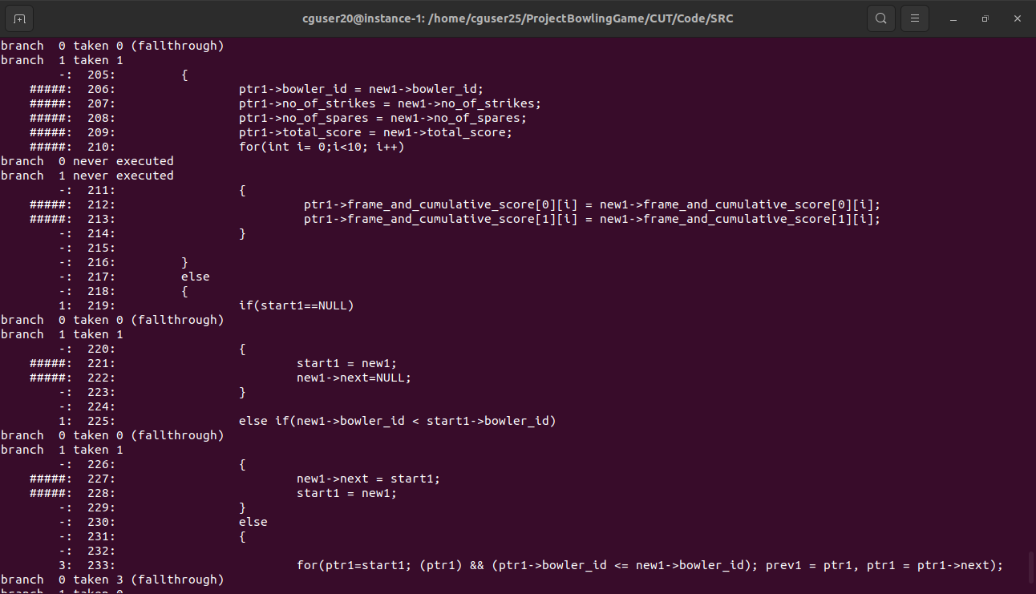

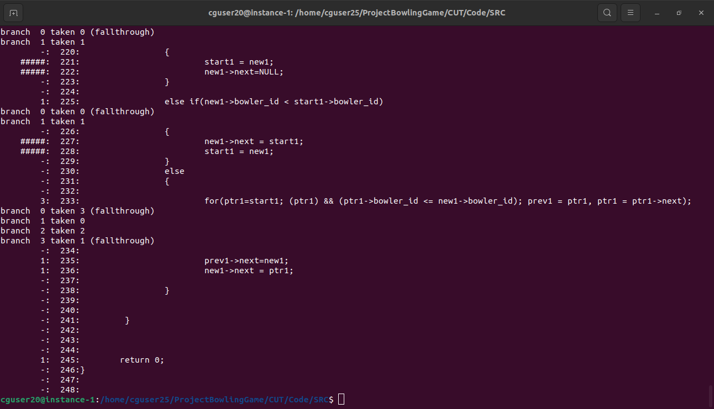

**6. Testing**

**6.1 Unit Testing**

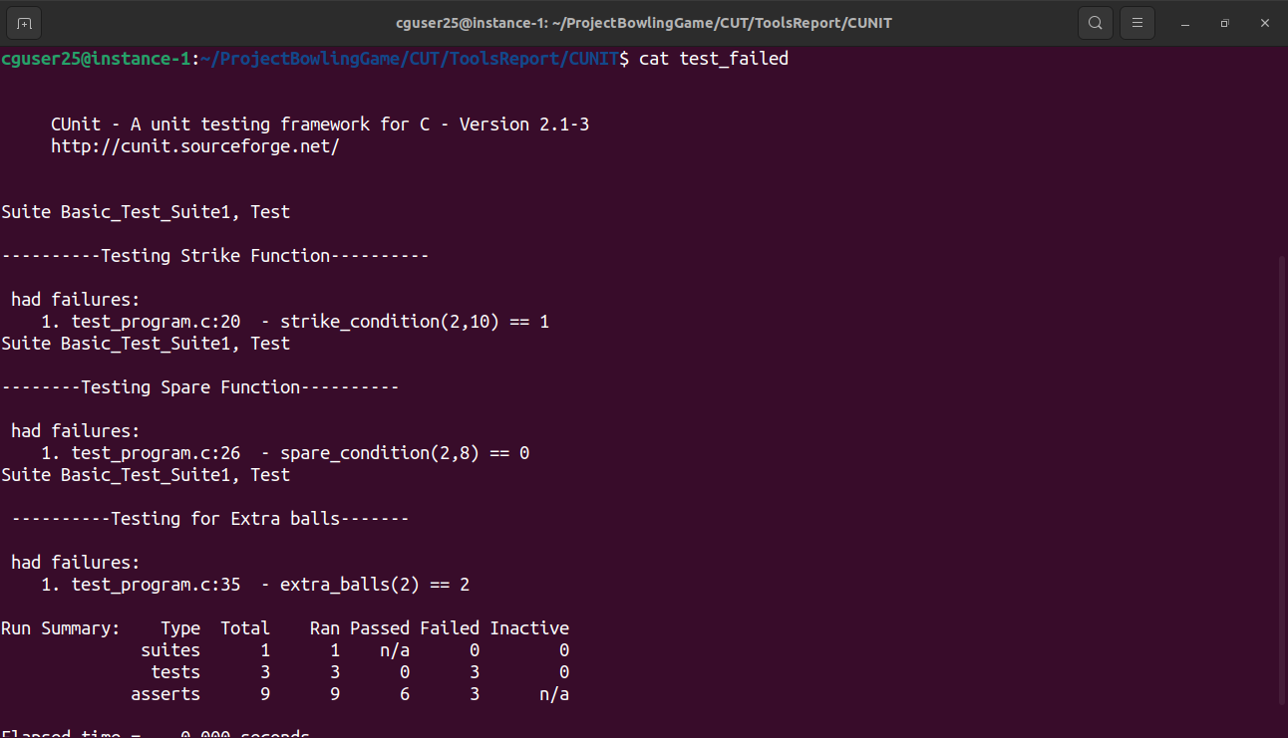

**6.2 Integration Testing**

**6.2.1 Add**

**6.2.2 Delete**

**6.2.3 Edit**

**6.2.4 View**

**6.2.5 Play the game**

**6.2.6 Bowler data sheet**

**6.2.7 Bowler day report**

**7. Requirements Traceability Matrix(RTM)**